

**Canteen Ordering System**

Project by:

**Mohit Pal**

Table of Contents

1- Introduction: 2

1.1 Project Overview: 3

1.2- Business Analysis Core Concept Model (BACCM) 3

1.3- Requirements Classification Schema (RCS) 4

2- Stakeholders Involved 5

3- Problem statement 6

4- Objectives of the new Canteen Ordering System 7

5- As-is and future process map (using flowcharts) 8

6- Scope of the Canteen Ordering System (Context Diagram) 9

7- Main features that need to be developed 10

8- The in-scope and out-of-scope items for the system 10

9- Swim-lane diagram for the system 11

10- An ER diagram for the system 12

11- The functional and non-functional requirements 13

12- Wireframes for the Canteen Management System 14

# 1- Introduction:

Unilever is a British-Dutch MNC FMCG company, headquartered in London, England. Unilever is one of the oldest FMCG companies, and its products are available in around 190 countries. In its UK offices, Unilever had around 1500 employees which were spread across 12 floors.

### 1.1 Project Overview:

The company has 2 canteens in the UK office which accommodates 150 employees each at a time. Most employees would prefer to take their lunch between 12 noon to 1 pm. This led to a huge rush in the canteen during lunch hours resulting in employees wasting a lot of time waiting for tables to be vacant. Management calculated that it took around 60 minutes for employees to go and come back from lunch. This is affecting the effective work life and productivity of the employees. Employees don’t always get the choice of food they want because the canteen runs out of certain items. The canteen wastes a significant quantity of food by throwing away what is not purchased.

* Lunch Hour (to go and come back from lunch) - 60 minutes
* Waiting in a queue to collect their food - 30-35 minutes
* Time spent eating - 10-15 minutes
* Coming back from the canteen using the elevators - 10 minutes

### 1.2- Business Analysis Core Concept Model (BACCM)

|  |  |
| --- | --- |
| **Need** | The need is to have an online canteen ordering system which can reduce food wastage, operating costs, manpower and increase employee’s work time. |
| **Change** | The change is to automate the current canteen system to an online meal ordering system. |
| **Solution** | The solution is to develop an online canteen ordering system in Java, that will allow the canteen users to order their meals and get it delivered to their workspace. |
| **Context** | The context leading to change is that the company has to cater to 1,500 employees during lunchtime (12-1 pm). This causes huge rush in the canteen and leads to waste of employee’s time waiting for the seat. |
| **Value** | The value added with the new system are:   * Saves manpower and employee time so increases efficiency * Low operational cost and less wastage of food * No rush in the canteen during lunchtime |
| **Stakeholder** | External stakeholders:   * Supplier * Employees * Payroll team * Canteen manager * Meal deliverer   Internal stakeholders:   * Project Manager * Implementation SME * Operational IT team * Testers * Chef   Business Analyst |

### 1.3- Requirements Classification Schema (RCS)

* **Business requirements:** To automate the canteen ordering system by developing an online food ordering portal for the company that can increase efficiency and save time and manpower.
  + Reduce canteen food wastage by a minimum of 30% within 6 months following first release.
  + Reduce canteen operating costs by 15% within 12 months, following initial release.
  + Increase average effective work time by 30 minutes per employee per day, within 3 months.
  + By making the ordering process automated and by delivering the food to the user's workstation, the canteen will be able to operate with less manpower.
* **Stakeholder requirements:** The key stakeholders are employees, the canteen manager, the meal deliverer, payroll manager.
  + **Employees:** The users will be able to log in and order food online through the system. The food will be delivered at their workspaces and the amount of the meal will be deducted from their monthly salary.
  + **Canteen Manager:** The canteen manager should be able to view the orders, take the inventory of all the orders, and get them cooked by the chef. The manager should be able to request a delivery to the employees’ workstations.
  + **Meal delivery person:** After successful delivery of the meal the delivery boy should be able to close the online customer order.
  + **Payroll team:** The team needs to calculate the total number of dishes ordered by each employee. and shall deduct money from the employee’s salary.
* **Solution requirements:** 
  + Functional requirements: An online web portal or mobile application is required to be developed to automate the canteen food delivery system. The system will be created and maintained on Java as it requires very little maintenance to be done on the code.
  + Non-functional requirements: This canteen ordering system is required to support a volume of 1500 employees ordering, so the web pages should be light and render fast. The system should be scalable, self-explanatory, and user-friendly.
* **Transition requirements:** The users of the system should be trained enough to use it efficiently. A helpdesk team can be arranged to assist in case any errors or problems are faced by the users while using the system.

## 

# 2- Stakeholders Involved

RACI Matrix is used for identifying the responsibility of each stakeholder involved in the process :

* **Responsible (R):** the persons who will be performing the work on the task
* **Accountable (A):** the person who is ultimately held accountable for the successful completion of the task and is the decision-maker
* **Consulted (C):** the stakeholder or stakeholder group who will be asked to provide an opinion or information about the task
* **Informed (I):** a stakeholder or stakeholder group that is kept up to date on the task and notified of its outcome.

|  |  |  |  |  |
| --- | --- | --- | --- | --- |
| **Stakeholders** | **Responsible (R)** | **Accountable (A)** | **Consulted (C)** | **Informed (I)** |
| Supplier |  |  |  | **I** |
| Project Manager |  | **A** |  |  |
| Implementation SME | **R** |  |  |  |
| Operational IT team | **R** |  |  |  |
| Testers | **R** |  |  |  |
| Domain SME |  |  | **C** |  |
| Chef |  |  | **C** |  |
| Canteen manager |  |  | **C** |  |
| Employees |  |  |  | **I** |
| Meal deliverer |  |  | **C** |  |
| Payroll team |  |  |  | **I** |
| Business Analyst | **R** |  |  |  |

# 3- Problem statement

Unilever has around 1500 employees all of which are spread across 12 floors. The company provides food service via 2 canteens that serve all 1,500 employees. Employees prefer to have lunch between 12 and 1 p.m. Each canteen seats around 150 employees at a time. This led to a huge rush in the canteen during lunch hours resulting in employees wasting a lot of time waiting for tables to be vacant.

To alleviate overcrowding of the canteens, reduce costs, and improve service to employees, management has embarked on a project to create an automated system that will allow employees to order their lunch for eating at their workstations. Furthermore, employees have complained that many of their favorite food items were not available by the time their lunch hour arrived. An automated ordering system will track which foods are most popular and help meet the higher demand.

The above problem scenario is represented by the Fishbone diagram below:

*Fig. 1: Fishbone diagram*

# 4- Objectives of the new Canteen Ordering System

1. Reduce canteen food wastage by a minimum of 30% within 6 months following first release. Thevalue of food thrown away each month by examining the canteen inventory:

Previous - 25% wasted

Must plan for - Less than 15%

1. Reduce canteen operating costs by 15% within 12 months, following initial release.
2. Increase average effective work time by 30 minutes per employee per day, within 3 months.
3. By making the ordering process automated and by delivering the food to the user's workstation, the canteen will be able to operate with less manpower.

The above business requirements are represented below in Mind Map:

*Fig. 2: Mind map*

# 5- As-is and future process map (using flowcharts)

*Fig. 3: As-is process map*

*Fig. 4: Future process map*

# 6- Scope of the Canteen Ordering System (Context Diagram)

The scope of the canteen management system has 5 components: Unilever management, Unilever employees, Canteen management, Meal Deliverer, and the payroll team.

*Fig. 5: Context diagram*

# 7- Main features that need to be developed

Below are the main features of the system which needs to be developed:

1. Employee registration and login on the system
2. After successful login, an employee should be able to see the updated food menu with all the dishes
3. The lunch orders cannot be made after 11 am so that the chef has sufficient time to prepare the lunch for all the employees
4. Employee can place the lunch order and confirm after adding all the desired food items to their cart
5. Once the order is confirmed, the employee cannot modify or cancel the order
6. The canteen manager (order processor) views all the order and assign them to chef for the preparation
7. The packed order will be assigned to the meal deliverer for the delivery to employee’s workstation
8. After the food is delivered, the meal deliverer will mark the order as closed
9. After completion of the order, the employees will be asked to fill out the feedback form for their order
10. There will be no payment gateway so the bill amount will be deducted from the employee’s monthly salary by the payroll team

# 8- The in-scope and out-of-scope items for the system

**In-scope requirements:**

* Only 1,500 Unilever employees may order food. Here, a login page to validate the users must be created. It will help in authorization and authentication. Menu page
* Employees may order food during weekdays between 12 noon to 2 pm. Payment Summary
* Food delivery is applicable/applied to employees working from the office. Not for those WFH. Meal delivery details
* Employees may select the food from the given menu only.

**Out-of-scope requirements:**

* No other person /employee outside Unilever is authorized to order food. Food supplies out of stock notification
* No one would be allowed to place an order beyond the given range i.e., 12 noon to 2 pm. Weekend and holidays it is not applicable. Chef and meal delivery person pay details
* Food delivery is prohibited or restricted outside the office premises.
* No selection is possible for food items not available as part of food inventory.

# 9- Swim-lane diagram for the system

*Fig. 6: Swimlane activity diagram*

# 10- An ER diagram for the system

*Fig. 7: Entity Relationship (ER) Diagram*

# 11- The functional and non-functional requirements

* **Functional requirements:** The canteen management system (CMS) has the following functional requirements:
  + Online web or mobile application
  + Signup / Login screen to verify employee’s details (Only Unilever employees should be allowed to sign up with their employee ID)
  + Menu for food selection
  + Food ordering not allowed post 11 am
  + Food order and payment summary
  + Order tracking feature
  + Payroll management system
  + Meal delivery person details
  + feedback submission
* **Non - functional requirements:** CMS has the following non - functional requirements:
  + Usability: User-friendly system and self-explanatory screens
  + Scalability: Able to serve 1500 users of the office
  + Performance: The system should be light and render fast
  + Platform: Java platform as it required very little maintenance to be done on the code

# 12- Wireframes for the Canteen Management System

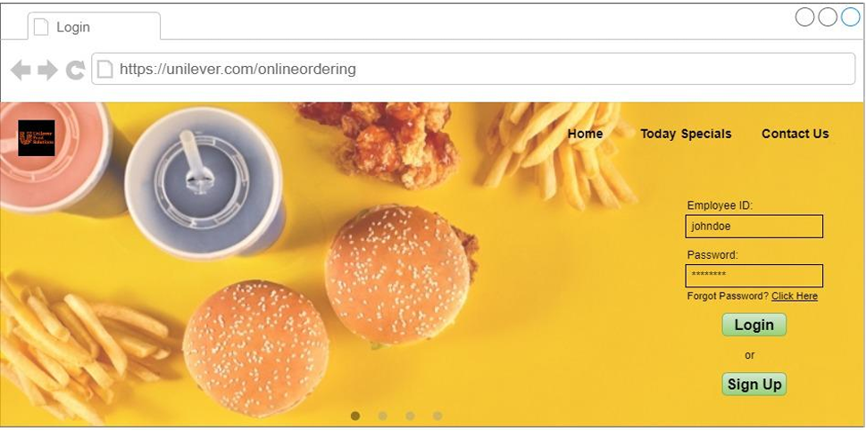

*Fig. 8.1: Registration page*

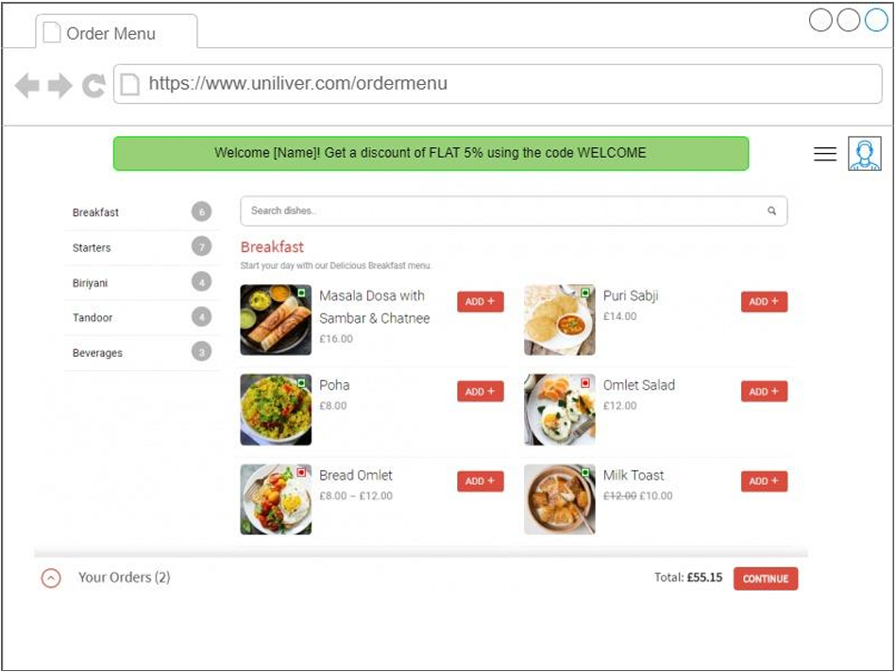

*Fig. 8.3: Food menu page*